3

Some useful information:
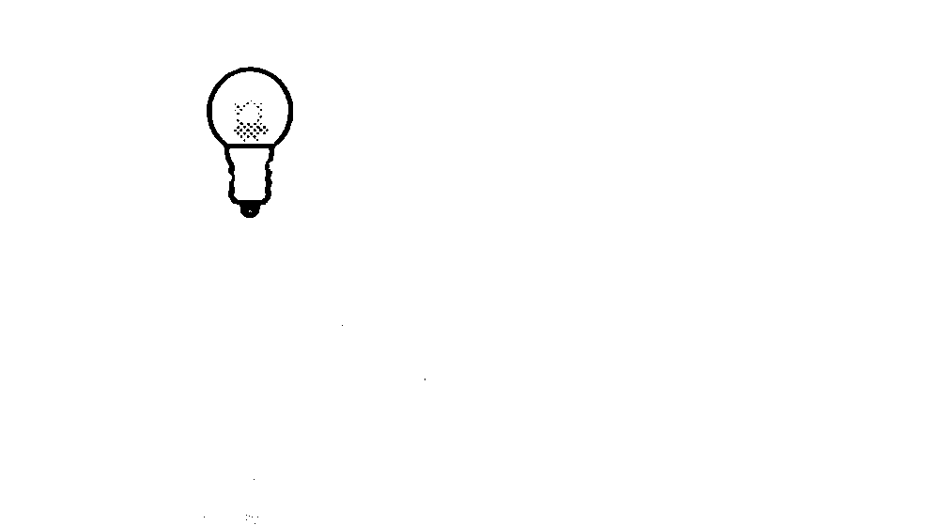
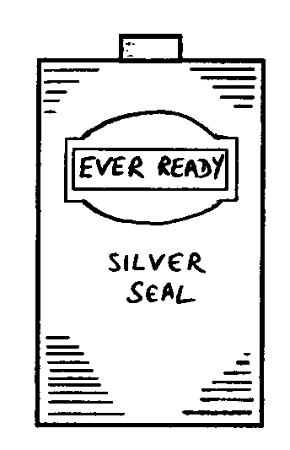  The two contact points on a torch battery are at the ends: |  | The two contact points on a torch bulb are the tip and the screw thread:

Look at each of the circuits below. Tick one box () to show if the bulb is lit or not.

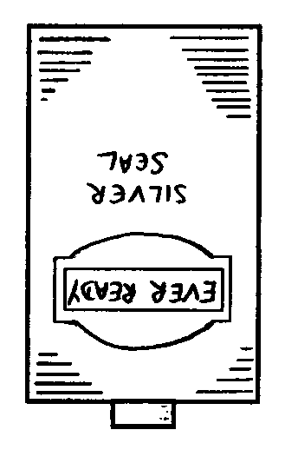
.

not lit
lit
a. b.
.

not lit
lit

c.
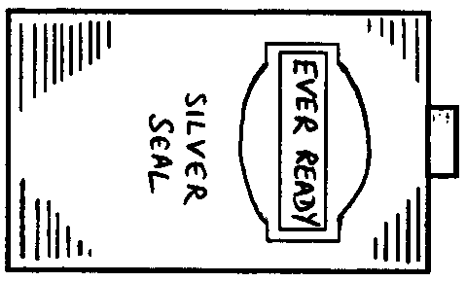
.

not lit
lit

